Project Increment 1
AI Chat based Survey System

Team mates – Roshna Toke (26), Sahithya Gadde (6)
Nagababu (4), Bharani Yellanki(27)

Objective:
The main objective of this project is to create an AI driven feedback tool. Collecting responses from the users is most important touchpoint for most of the companies. And a recent survey results also predict that most of the users prefer conversational experience is far better than traditional survey experiences. By using this conversational interface an organization can interact with their customers more effectively and get to know about their opinions and what they really want. Conducting this kind of surveys frequently helps the organization to grow.

Procedure:
Here we are creating a chatbot which interacts with the users, ask’s them questions and get back either audio or text responses. Then the responses received from the survey through the chatbot are analyzed using sentimental analysis. The responses received are classified into three types: Positive, negative and neutral and the corresponding statistics are displayed on the dashboard. In the web application which we are going to create there are three admins: Global Admin, Organization Admin and the users. The Global admin has access to everything. He can create new organizations, assign organization admins and assign roles to users. The organization admin can create/assign users to the organization, new question sets and assign them to the organization. Users will start the survey based on the question sets and these are the ones who forward the links to the students, workers, customers etc., based on the type of organization. The results of the survey shown in dashboard can be accessed by both users and organization admin, so that they can take appropriate measures. The Question sets, responses from the survey (both text and audio), Details of the organization and users are stored in the Database.

Implementation:
In this project we are using MEAN Stack for building the dynamic web application. MEAN is a full stack JavaScript framework which is used to develop web application using MongoDB, Express JS, Angular JS and Node JS. Mongo DB is the Database and Express JS and Node JS are Server-Side Scripting Languages whereas, angular JS is Client-Side Scripting Language. And by using Node JS we are creating a chatbot which asks the questions dynamically based on the responses given by the end-user taking the survey. And coming to analyzing the responses received from the end-user we are using different machine learning algorithms for Collecting the features, filtering the features with high priority and then determine the emotion of the end user.

Web Application:
- Registration Page

This is the screenshot of the registration page. First time user should sign up before he can login to the application and all the fields in this page are mandatory. We have also included some validations like both password and confirm password are same and check all the fields are filled up after the user clicks sign up.
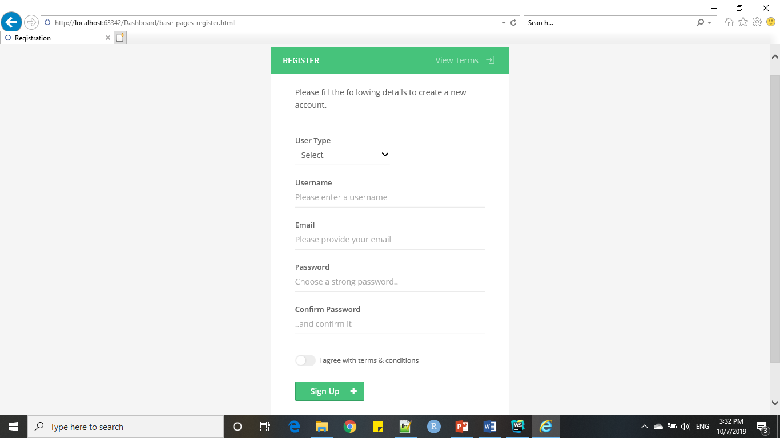

- Login Page

This is the screenshot of the login page. Here as the user enter’s his/her details it will check automatically if the credentials match with any of the user’s who have registered and if it matched it navigates to home page. If the credentials do not match then it prompts that username or password is wrong.
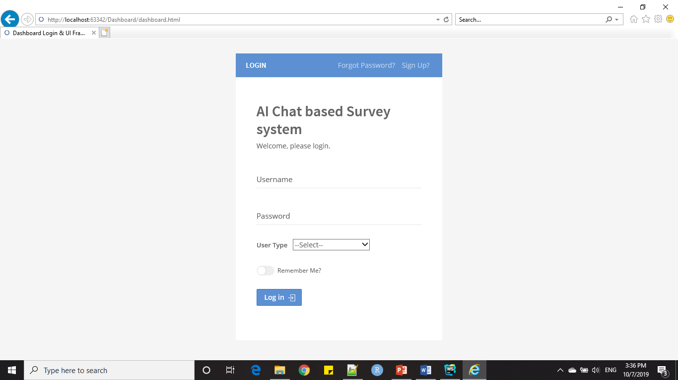

- Forgot Password
If the user forgets his/her password, then by clicking forgot password button he will be navigated to this page. Here as the user enters his email and clicks send email then an email with a new password will be sent to users account.
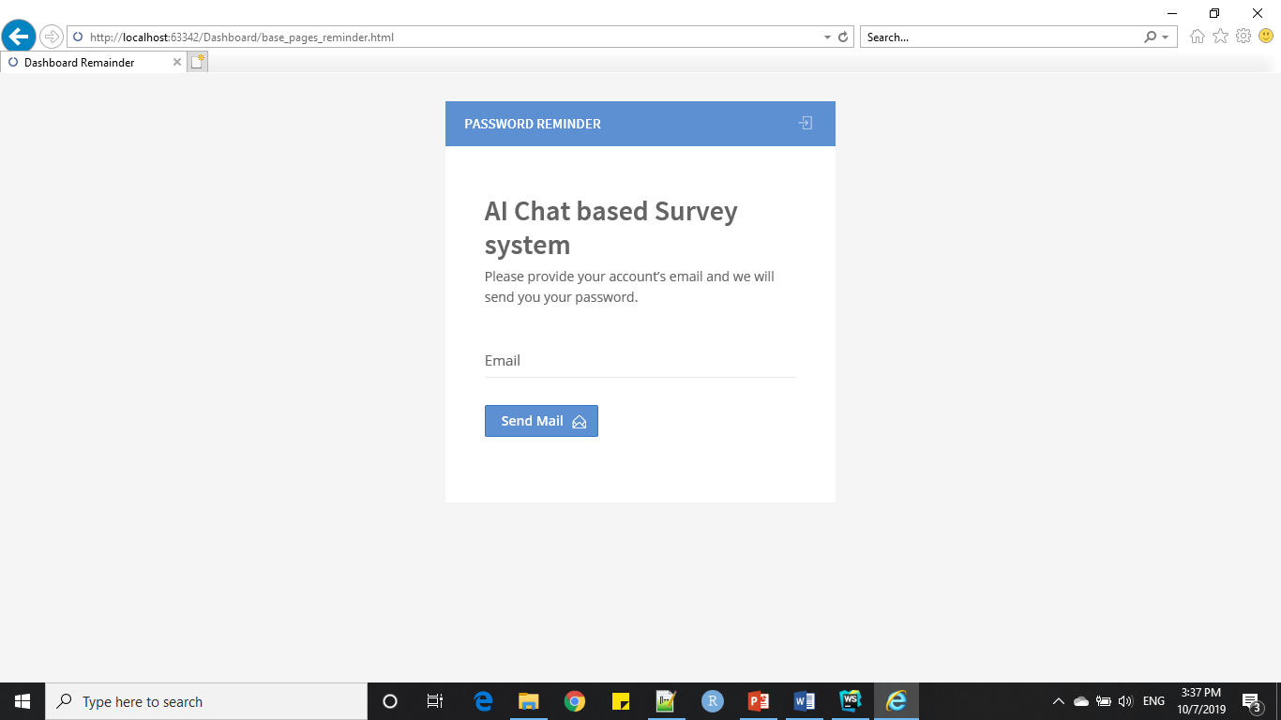

- This is the screenshot of the global admin page. Here the global admin can add, view, modify and delete organizations.
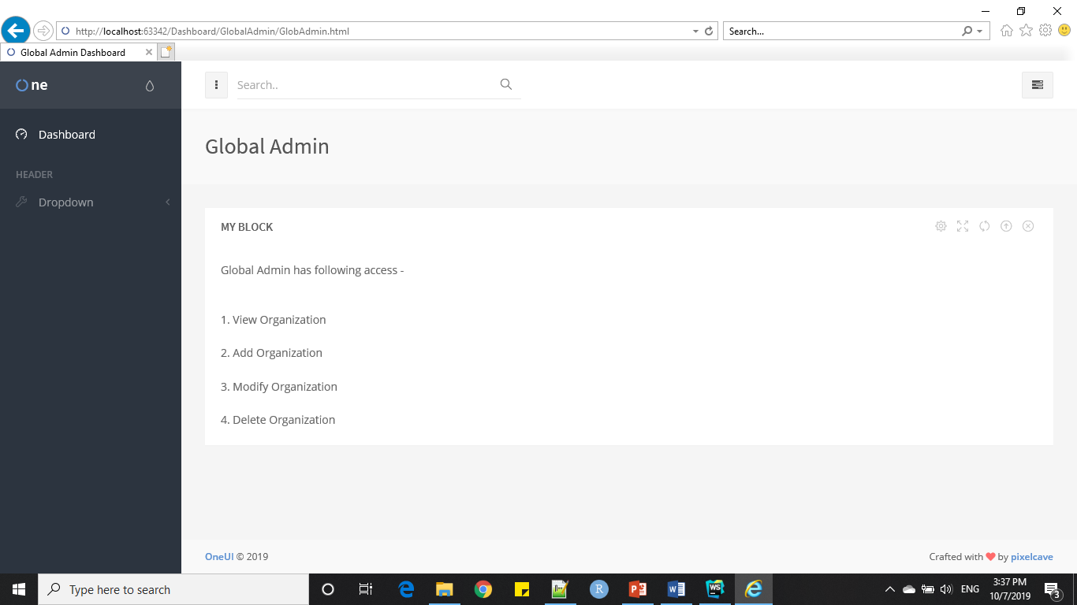

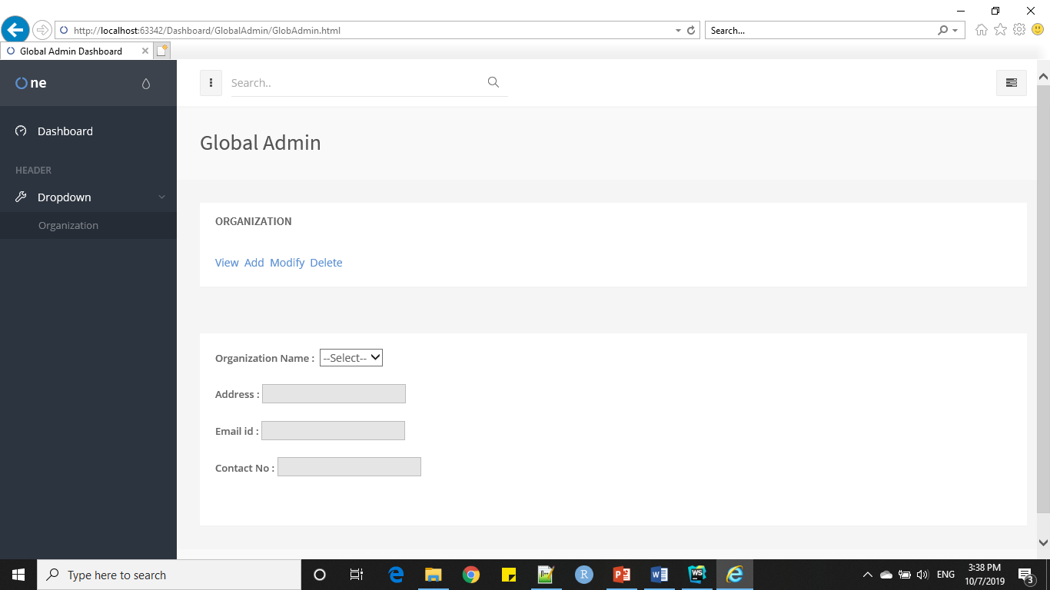

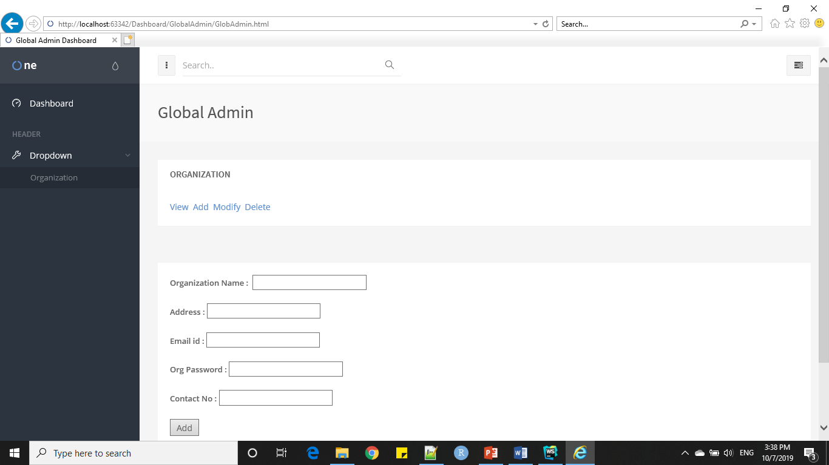

To Delete, User needs to select Organization Name
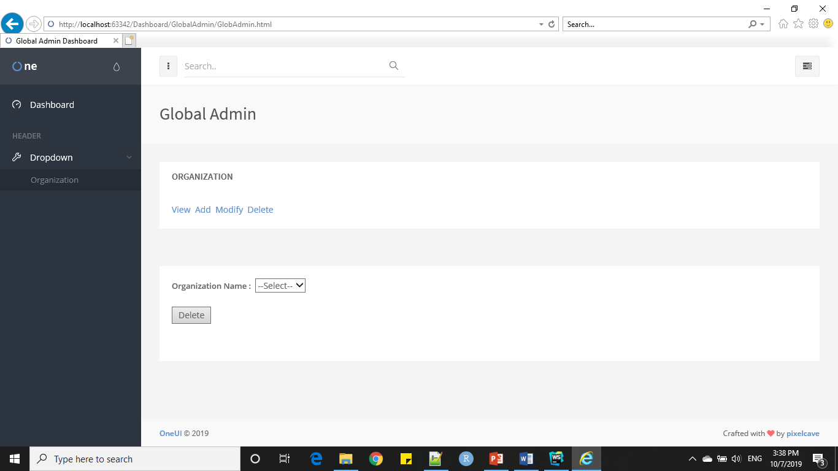

- If the user is an organization admin

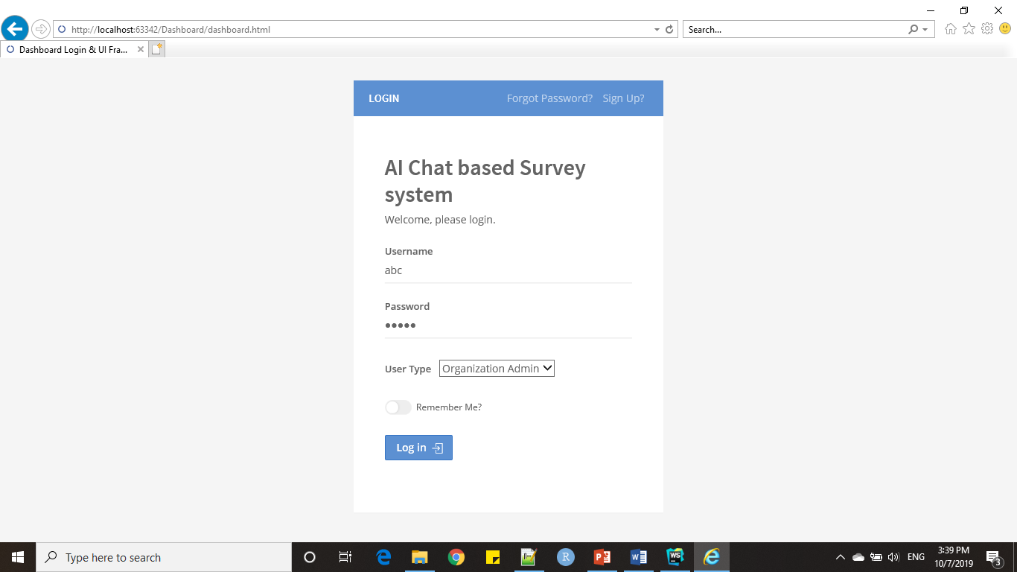

This is the home page of an organization admin. He/she can also view the results of the surveys created by the users.
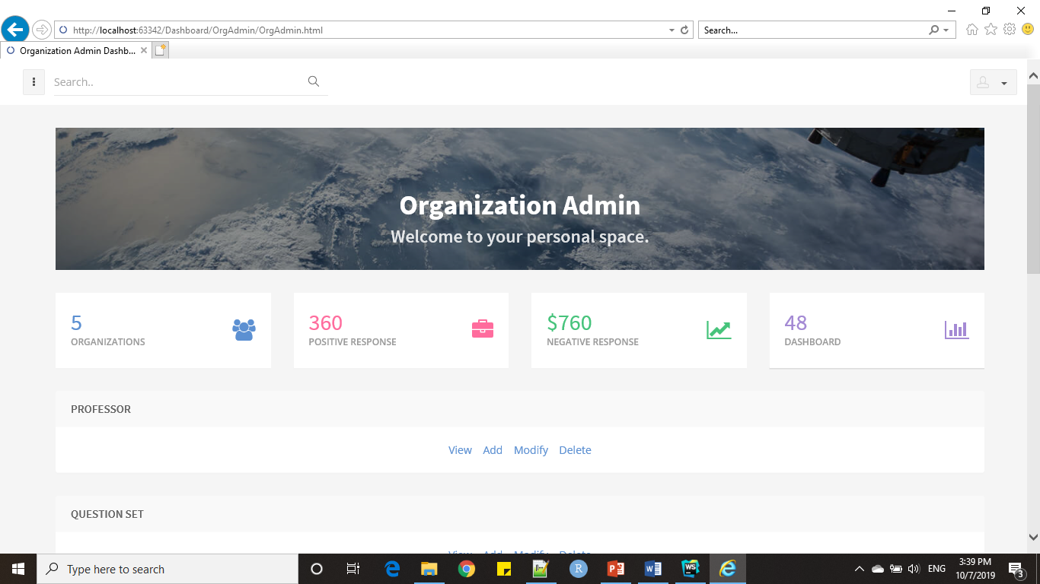

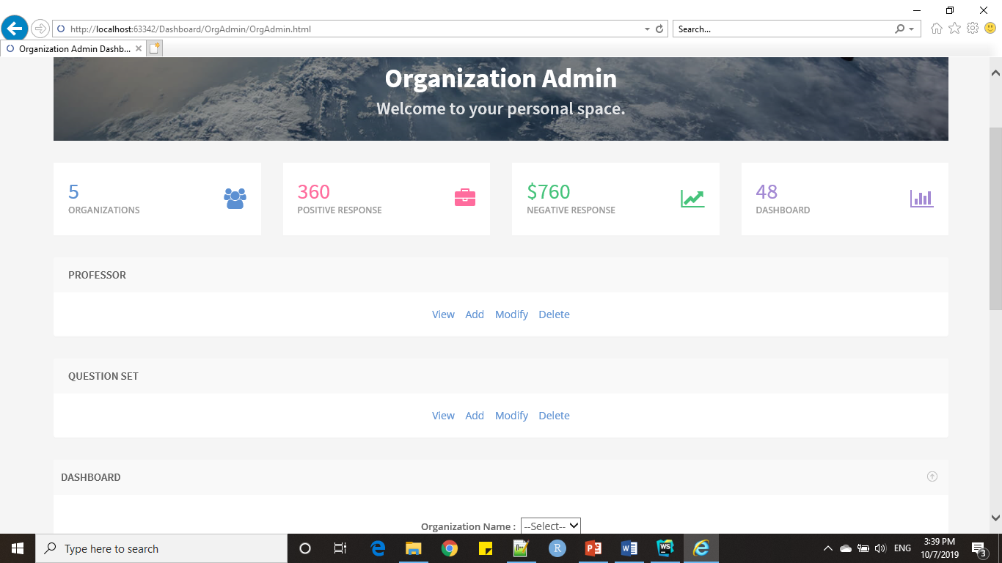

Here he/she(admin) can add, view, delete and modify users.
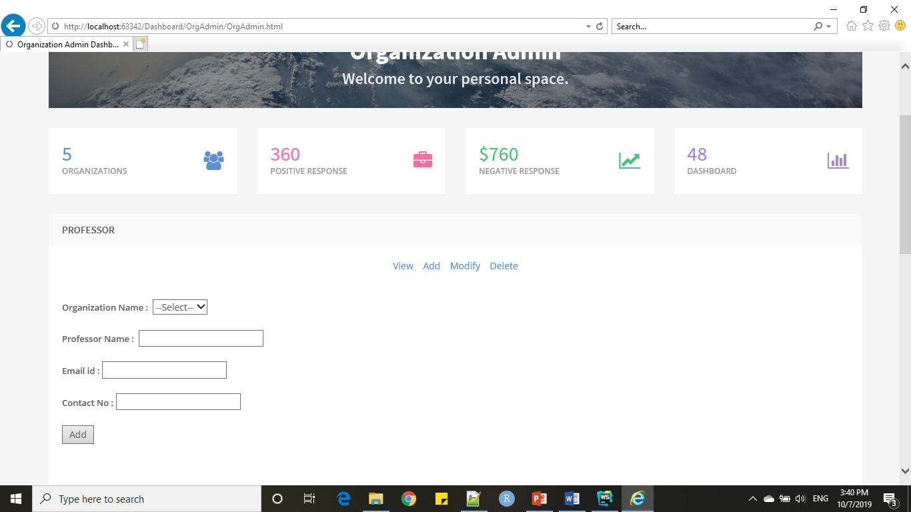

Here Organization Admin can delete professor data of particluar Organiazation.
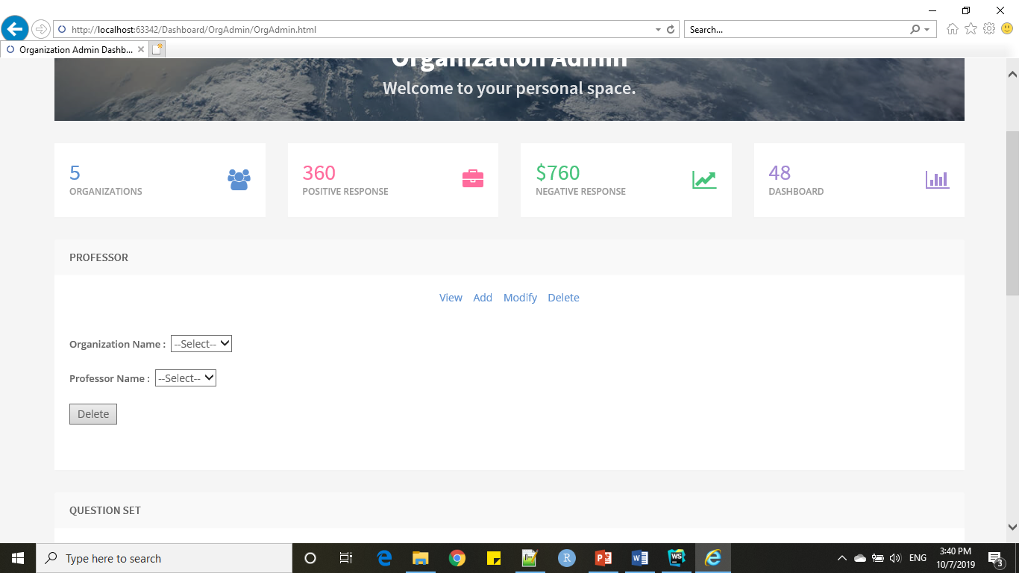
And this admin can add, view, modify and delete question sets. This is the screenshot of the web page where the admin can add question sets.
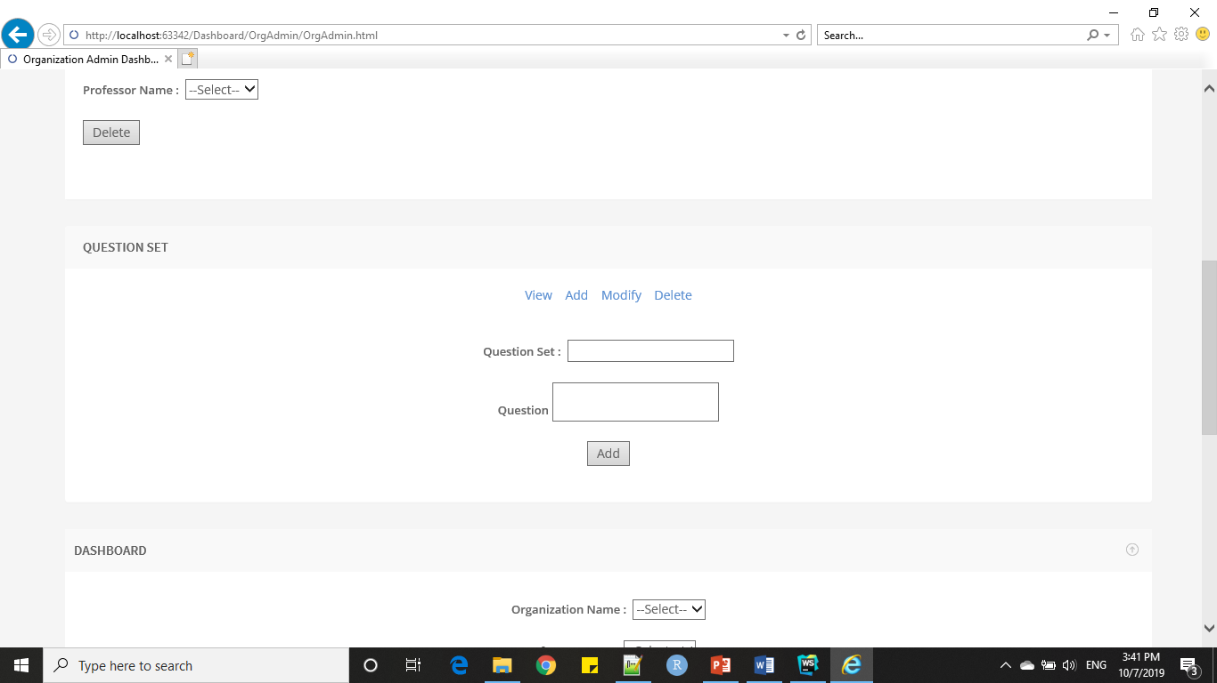

This is the screenshot of the web page where the admin can modify question sets.
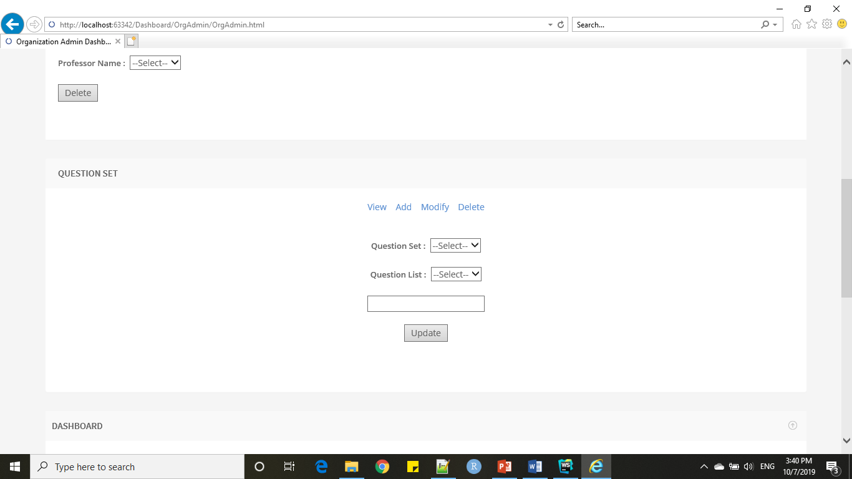

This is the screenshot of the web page where the admin can delete question sets.
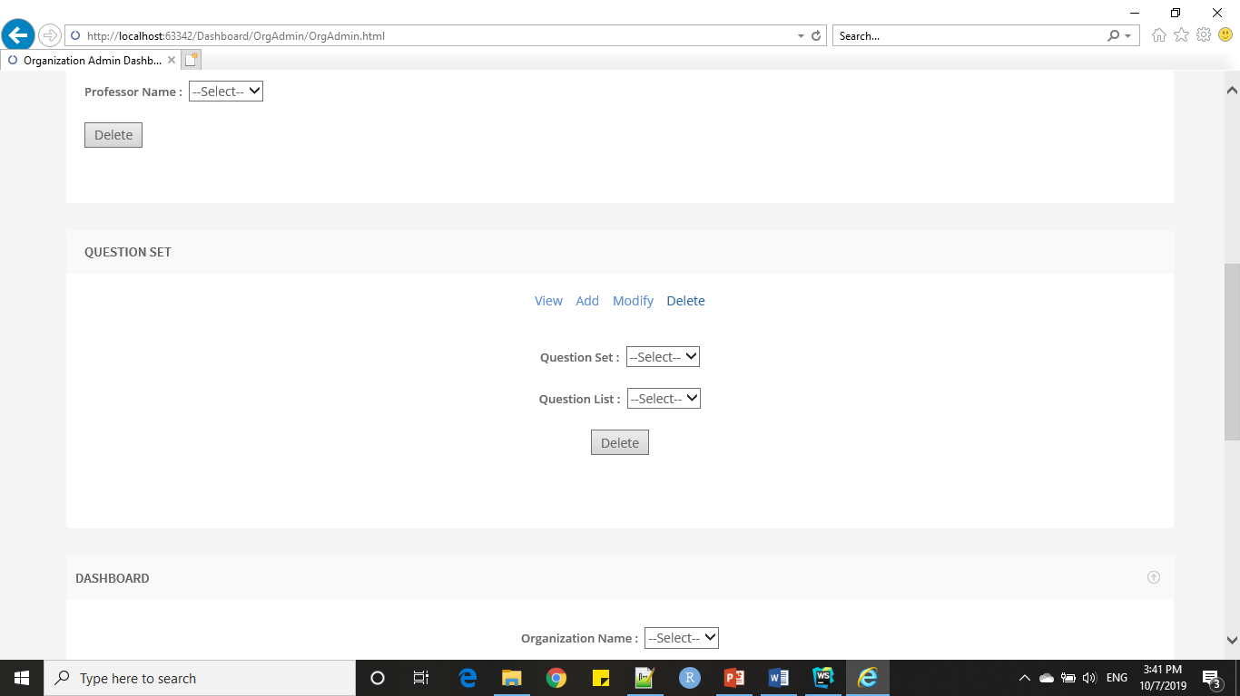

This is the screenshot of the dashboard of the organization admin where he can see the results of the surveys of any particular user by selecting his/her name.
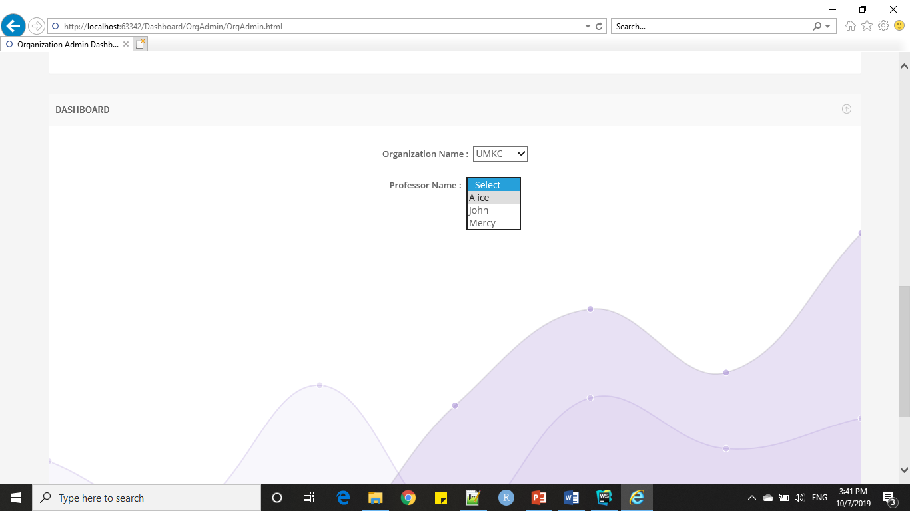

- User
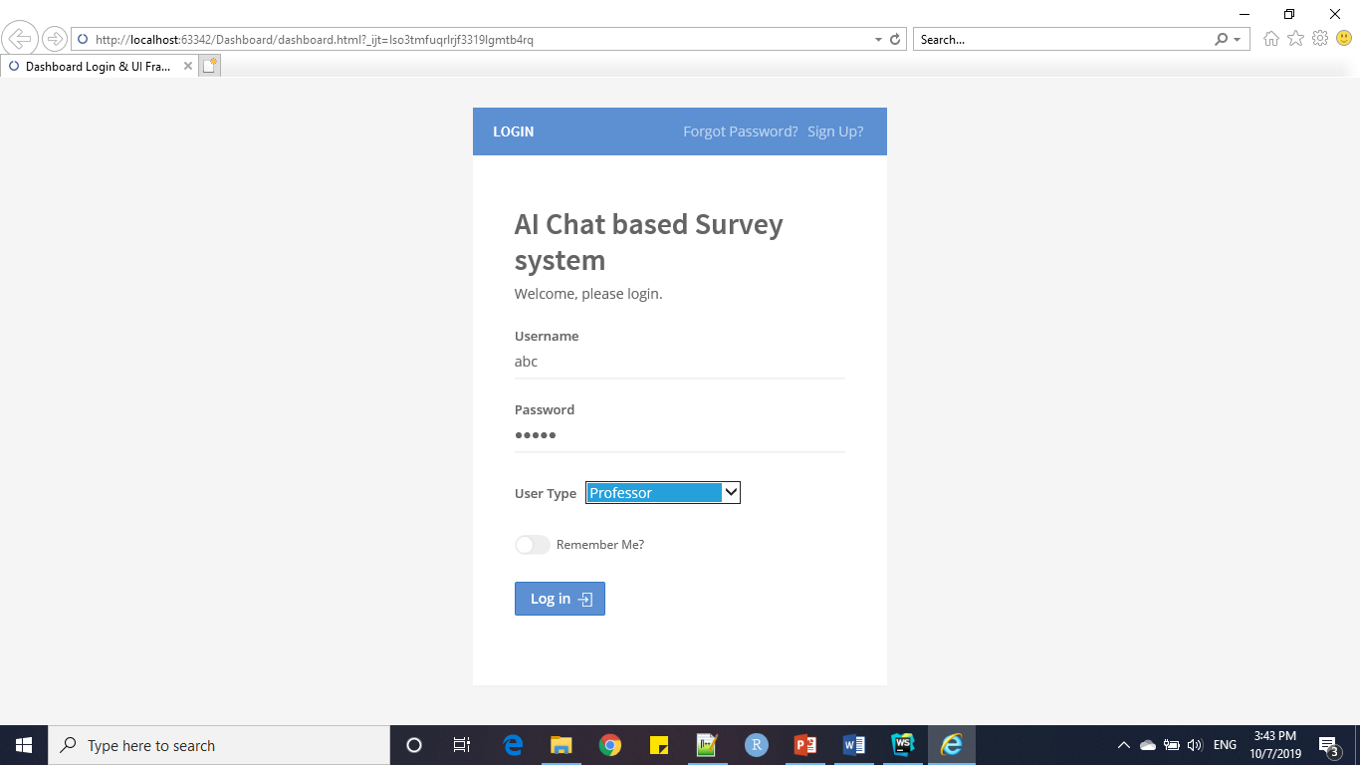
This is the Home Page of the user where he/ she can select one of the questions sets which are available and the user can also see the results of the survey in the user’s dashboard.
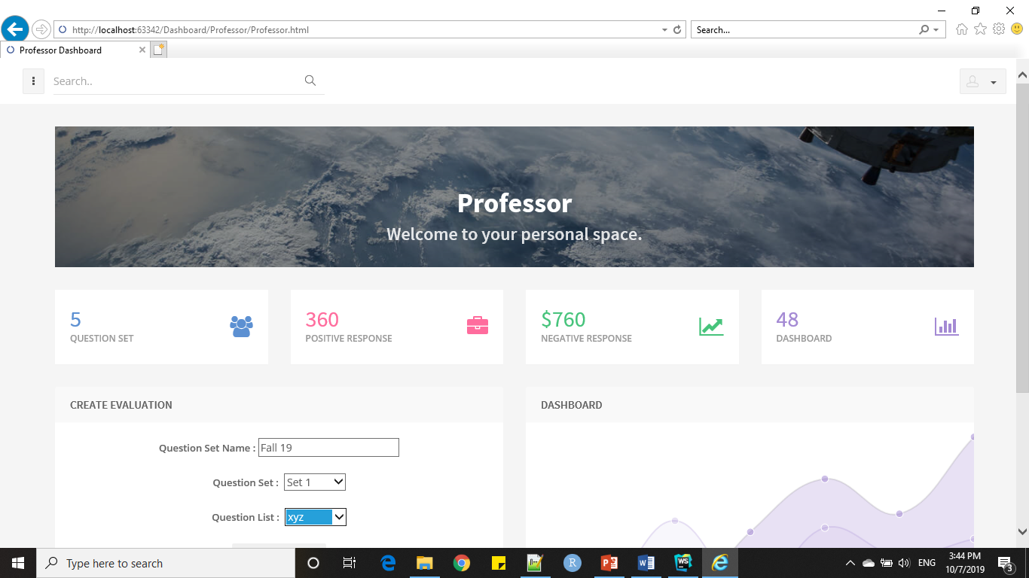
As the User(Professor) selects the question set and specifies the E-mail id of the students and click send button then the link using which a student can connect to the chatbot to take the survey will be sent to their respective Mail ID’s.
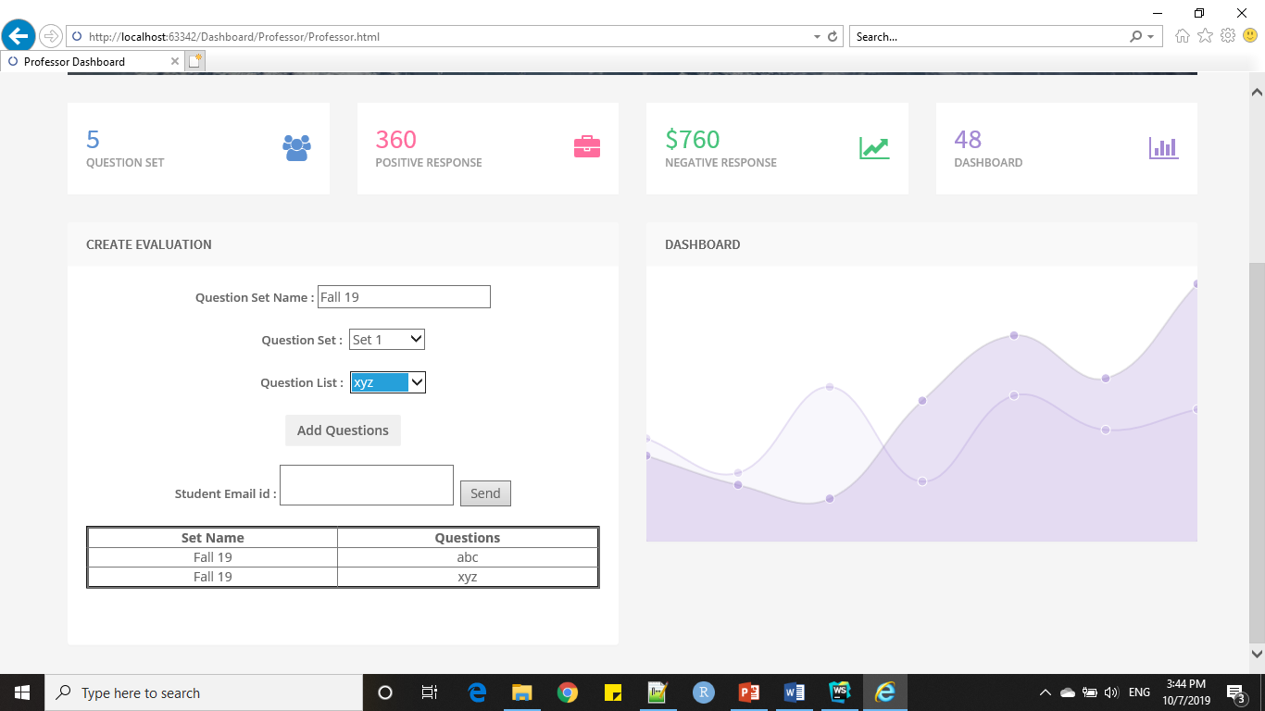

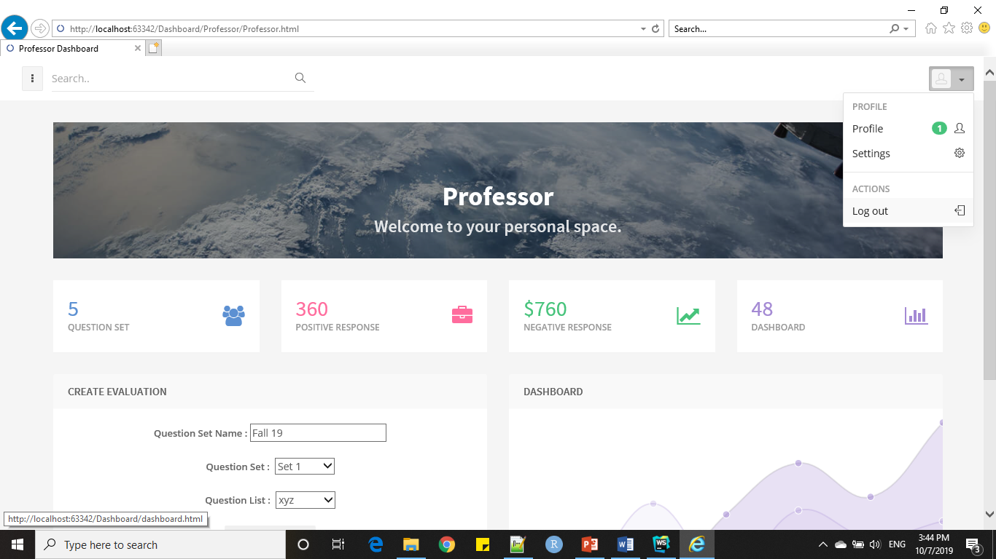

UML Class Diagram:
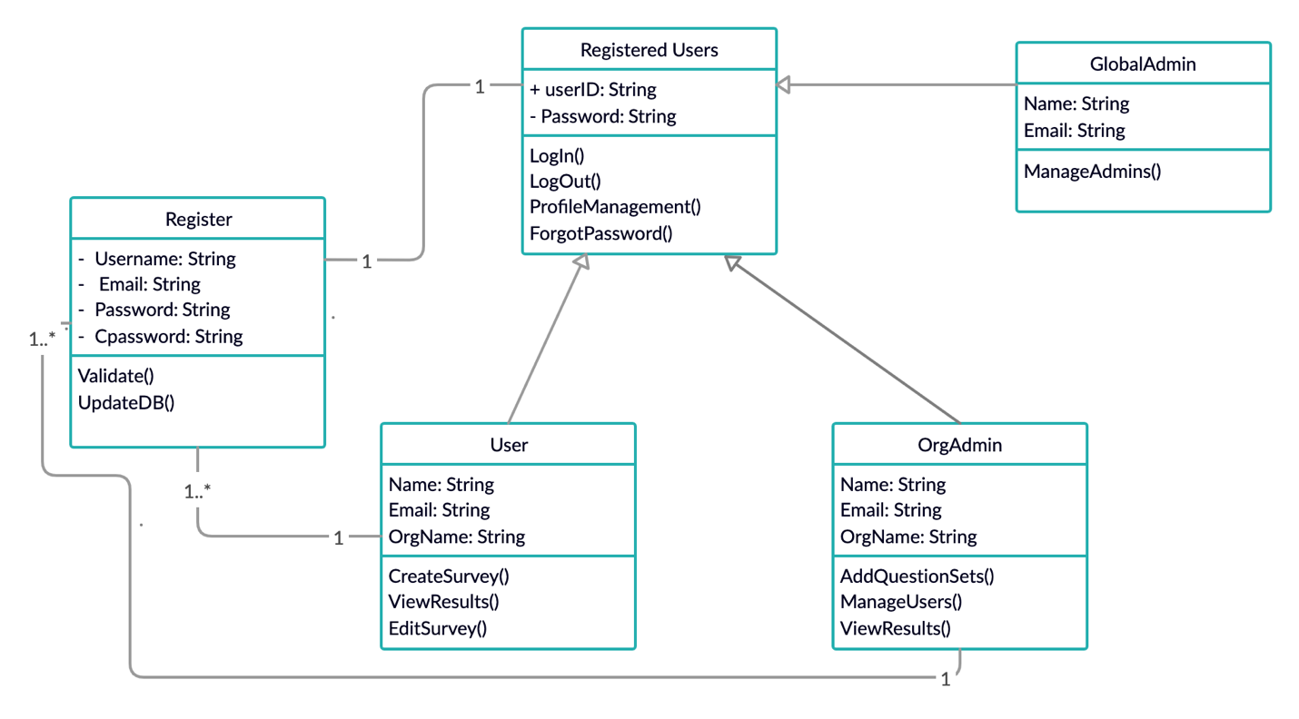

Use Case Diagram:
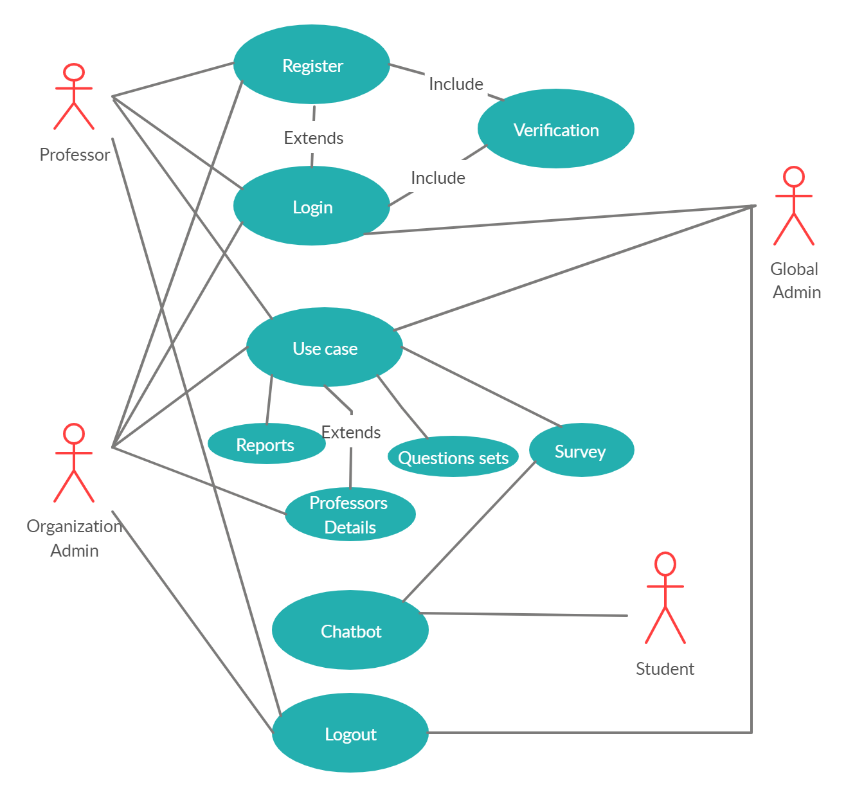

Burndown Chart:

